A
Minor Project Report
on
Stock Market Analysis using Machine Learning
Submitted for partial fulfillment for the degree of

Bachelor of Technology

(Information Technology)

in
Department of Information Technology

by

Jai Shanker Srivastava
169108065

Under the Guidance of
Mr.Ankit Mundra

(April-2019)

SCHOOL OF COMPUTING AND INFORMATION TECHNOLOGY

MANIPAL UNIVERSITY JAIPUR



CERTIFICATE

Date:27-April-2019

This is to certify that the project titled STOCK MARKET ANALYSIS USING MACHINE LEARNING is a record of the bonafide work done by JAI SHANKER SRIVASTAVA (169108065) submitted in partial fulfilment of the requirements for the award of the Degree of Bachelor of Technology (B.Tech) in Information Technology of Manipal University Jaipur, during the academic year 2014-15.

Mr. Ankit Mundra

Project Guide, Dept of Information Technology

Manipal University Jaipur

Dr.Pankaj Vyas

HOD, Dept of Information Technology

Manipal University Jaipur

ABSTRACT

Stock market analysis has attracted lots of research interests in the literature. Recent studies have shown that Machine learning algorithm achieved better performance than traditional statistical methods. This report introduces a relatively new machine learning technique, support vector machines (SVM) with the integrated approach of Long Short Term Memory concept (LSTM), to the problem in attempt to provide a model with better explanatory power. We used LSTM as a benchmark and obtained prediction accuracy around 99.2% for the integrated approach of SVM for the TATA Global markets. However, only slight improvement of SVM was observed. Another direction of the research is to improve the interpretability of the three gate model prepared for the deep analysis. We applied recent research results in LSTM model interpretation and obtained relative importance of the input financial variables. Based on these results, we conducted a market comparative predictive analysis on the differences of determining factors in TATA Global company.

LIST OF TABLES

Table No | Table Title | Page No
T.1 | Dataset | 7
T.2 | Timeline | 11

LIST OF FIGURES

Figure No | Figure Title | Page No
 | LSTM Model | 4
 | Model - 1 | 9
 | Model - 2 | 9
 | Model - 3 | 9
 | Final Model | 10
 | Flowchart | 7

 | Contents
 | Page No
Abstract | i
List Of Figures | ii
List Of Tables | iii

Chapter 1 INTRODUCTION

1.1 Introduction to work done/ Motivation (Overview, Applications & Advantages) 1

1.2 Project Statement / Objectives of the Project 2

1.3 Organization of Report 3

Chapter 2 BACKGROUND OVERVIEW

2.1 Conceptual Overview (Concepts/ Theory used) 4

2.2 Technologies Involved 5

Chapter 3 METHODOLOGY

3.1 Detailed methodology that will be adopted 6

3.2 Diagrams Involved 7

Chapter 4 IMPLEMENTATION AND RESULTS

4.1 Modules 8

4.2 Prototype 10

Chapter 5 FUTURE WORK AND CONCLUSION

5.1 Progress Chart/Time Line Chart 11

5.2 Future Work and Conclusion 11

REFERENCES 12

CHAPTER – 1

INTRODUCTION:

Stock market prediction has been in the limelight for many decades, but given its innate complexity and dynamism, it has proven to be a very difficult task. The number of variables and sources of information considered are immense and since there are a lot of locomotive factors affecting the price of the stock, it creates a very effective analysis prediction wise. That makes the task of predicting stock market prices behavior in the future a very hard one. For many decades, there's been discussions in Science regarding the possibility of such a feat and it's notable in the related literature that most prediction models fail to provide precise prediction in a general sense.

Nonetheless, there is huge amount of research from various disciplines seeking to take on that challenge, presenting a large variety of approaches to attain the supreme goal.

One common approach is to use Machine Learning algorithms to learn from price historic data to predict future prices. This goes in that direction but studying an specific method using recurrent neural networks. Such networks have a short term memory capability and the hypothesis to explore here is that this feature can present gains in terms of results when compared to others more traditional approaches in Machine Learning field.

The algorithm of choice here is the LSTM (Long-Short term memory) network. It's a type of recurrent network that has proved very successful on a number of problems given its capability to distinguish between recent and early examples by giving different weights for each while forgetting memory it considers irrelevant to predict the next output. In that way, it is more capable to handle long sequences of input when compared to other recurrent neural networks that are only able to memorize short sequences.

Historic price data from different stocks from the TATA stock exchange will be used as source of information for the network. Along with this data, a large amount of technical indicators will also be generated to feed the network as features. Upon this dataset the model will be trained, evaluated and will attempt to predict whether the price of a particular stock will go up or not in the next 15 minutes.

LSTM has three gates:
- The input gate: The input gate adds information to the cell state
- The forget gate: It removes the information that is no longer required by the model
- The output gate: Output Gate at LSTM selects the information to be shown as output

MOTIVATION:

The world is becoming more technologically advanced every day. Each day we are coming up with new technology or ideas related to it. Technology is spreading into almost every domain there is like medicine, law, finance, agriculture and so much more. So the motivation behind this project is to make the analysis of the stock market more easy. Earlier we used to make predictions of the stock based on its past data, and those readings turned out to be false sometimes, many a times due to human error. The stock market is very volatile and it tends to keep on changing. With the help of machine learning we can make this analysis more accurate and precise. This would help us to understand the stock market at a much better scale since we would be training the machine ourselves. And we hope to make investing in stocks easy and reliable.

OBJECTIVE:

The objective of this project is to analyze the stock market and give us the idea of the position of the stocks in future and also help us to plan as in where one should invest in stocks to get maximum profit. Also, with the help of this project, we get a hands on idea about the stock market as well as machine learning.
Furthermore, the aim is to study the applicability of recurrent neural networks, in particular the LSTM networks, on the problem of stocks market prices movements prediction. Assess their performance in terms of accuracy and other metrics through experiments on top of real-life data and analyze if they present any sort of gain in comparison to more traditional machine learning algorithms.

ORGANIZATION OF REPORT:

- Chapter1: Introduction

This section of the report contains the introduction of the project, its components and its aspects. The motivation to do this project has also been stated in this chapter. It also describes the objective of the project which is to analyze the stock market.

- Chapter2: Background Overview

This chapter contains the overall background of this project. It contains the conceptual overview which in turn contains the explanation of the concepts which are used and the theory related to those concepts.

- Chapter3: Methodology

Methodology is basically the approach which was applied in reaching our objective. This section contains all the planning, the processes, the concepts and algorithms which were applied to the project. The methodology also comprises the layouts and the diagrams which further make the understanding of the project easy.

- Chapter4: Implementation and Results

This is the technical and the final chapter of this project. This consists of the modules derived and the prototype created. This might also contain various snippets of code which were used to implement the prototype so as to learn the technical point of view and get to know the coding aspect of it. And in the end, the results of the created prototype are shared.

CHAPTER – 2

CONCEPTUAL OVERVIEW:

Ashish Pathak et al in [1] take two approaches towards the stock market analysis.
- Traditional Approach - This includes 2 types:
  - Fundamental Analysis: This analysis emphases on the company’s past performance and credibility. It is based on the theory that profitable companies will continue to be so since the uptrend is influenced by the rewarding nature of the market.
  - Technical Analysis: This focuses on predicting the prices by applying time series analysis on previous trends.
- Modern Approach – This again includes 2 types:
  - Qualitative Analysis: Nowadays, the world is connected through media and social networks. So, with the combined resources of news feed and twitter feed, general population sentiment about a company can be highlighted. Text mining and sentiment analysis are useful tools for such high scale analysis.
  - Quantitative Analysis: Using historical dataset, multiple machine learning models can be applied to give accurate results for future investments.

The work proposed by Tongda Zhang et al [2], convinces us that index values of stock markets are and commodity prices can provide useful information in predicting process. It was also concluded that the longer the period is, the more information we have and the higher resistance of our prediction to noise. In addition, it was noted that SVM (Support Vector Machine) algorithm is sensitive to the size of data. Thus, feature selection is essential while using SVM, in contrast to MART (Multiple Additive Regression Trees) algorithm, which requires less training data and prefers high dimensional feature set.

Rohit Choudhary et al [3] suggest that an optimal set of features selected by an algorithm to be used in an SVM. The goal of linear scaling was to independently normalize each feature component to a specified range so that the larger input attributes do not overwhelm smaller input values, which in turn help to reduce prediction errors.

When it comes to stock markets, in addition to its inherent complexity and dynamism, there has been a constant debate on the predictability of stock returns. [4] introduced the Efficient-Market hypothesis that defines that the current price of an asset always reflects all previous information available for it instantly. There is also the Random-walk hypothesis [5] which claims that a stock price changes independently of its history, in other words, tomorrow's price will only depend on tomorrow information regardless of today's price. Those two hypotheses determine that there are no means to accurately predict a stock price.

TECHNOLOGIES INVOLVED:

The following technologies were used for the project:
- Hardware

  - 4GB RAM
  - Intel core i5 processor

- Software

  - Google Colaboratory

Google Colab is a free cloud service and supports free GPU

  - Kaggle GPU

Generalized Processing Unit for Fast Processing. This benchmark shows that enabling a GPU to the Kernel results in a 12.5X speedup during training of a deep learning model.

  - Jupyter Notebook

IDE for Python Language

  - Python Libraries

    - Keras: It is an open-source neural-network library. Designed to enable fast experimentation with deep neural networks, it focuses on being user-friendly, modular, and extensible.
    - Pandas: pandas is a software library written for the Python programming language for data manipulation and analysis. In particular, it offers data structures and operations for manipulating numerical tables and time series.
    - SkitLearn: Scikit-learn is a free software machine learning library for the Python programming language. It features various classification, regression and clustering algorithms including support vector machines, etc.
    - Matplotlib: Matplotlib is a plotting library for the Python programming language and its numerical mathematics extension NumPy. It provides an object-oriented API for embedding plots into applications using general-purpose GUI toolkits.

CHAPTER – 3

METHODOLOGY:

A classification model (Figure 2) was designed based on LSTM networks so as to perform predictions of price movements for a number of stocks. In other words, it attempts to determine if the price of a particular stock will be higher or not than the current price in 15 minutes in the future.

That model is regenerated and trained each trading day on top of historic price data and it is used for performing predictions each 15 minutes using the same model and weights until the end of the day.

Historic price data for particular stocks are gathered in the format of a time series of candles (open, close, high, low and volume) in a granularity of 15 minutes. For this report, data from 2010 to 2017 was collected for stocks that part of the NSE of TATA Global company.

With the data in hand, a log-return transformation is performed as means of normalization as well as to stabilize the mean and variance along the time series. The log-return transformation can be expressed as (1):

log(pi)−log(pi−1)(1)

On top of the historic price data, in order to reduce random variation and noise on the pricing series, exponential smoothing was performed through exponentially weighted moving averages (2) as indicated by [19] to cause improvements on the prediction capability.
Also on top of the price data, a set of technical indicators is generated using the TA-Lib1 library. Such indicators are mathematical calculations intended to determine or predict characteristics from stocks based on their historic data. A total of 175 values are generated for each period, and they are intended to represent or predict a very diverse set of characteristics of the stock, like the future price, volume to be traded, the intensity of the current movement tendency, visual graphical patterns, among others.

zi=λx¯i+(1−λ)zi−1(2)

A binary class y is assigned to each entry of the dataset, “1” will indicate that the price will go up on the following time step, and “0” that it won't. Therefore, given that i is the current moment and j is the following, then j=i+timestep, and for this project timestep is equivalent to 15 minutes. In case the output is “1”, a “buy” operation will be triggered at i.

For determining the class, the policy to set the value will be based on whether or not the closing price of the next period will be higher than the current one:

y={10if closej>closeiif closej≤closei(3)

The network will take k instances of X as input (Xi−k…,Xi−2,Xi−1,Xi), where X consists in tuples of price data along with technical indicators, and that will be used to predict yj.

DIAGRAMS INVOLVED:

Flowchart of the Project:

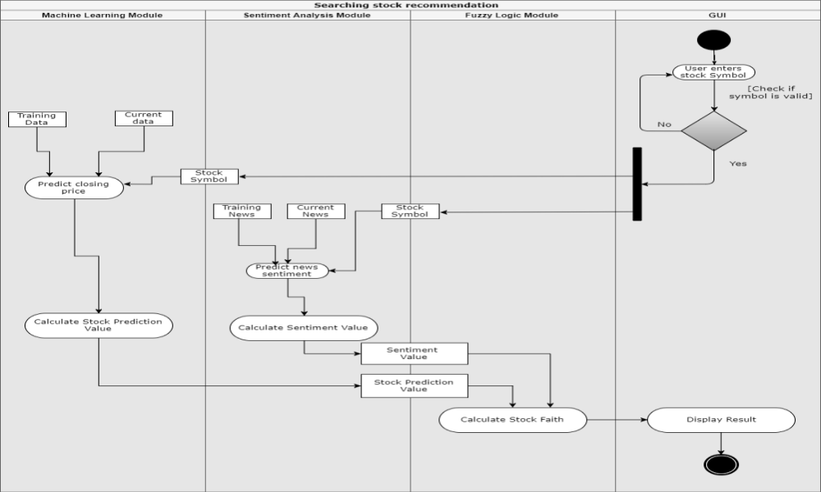

Dataset Used:

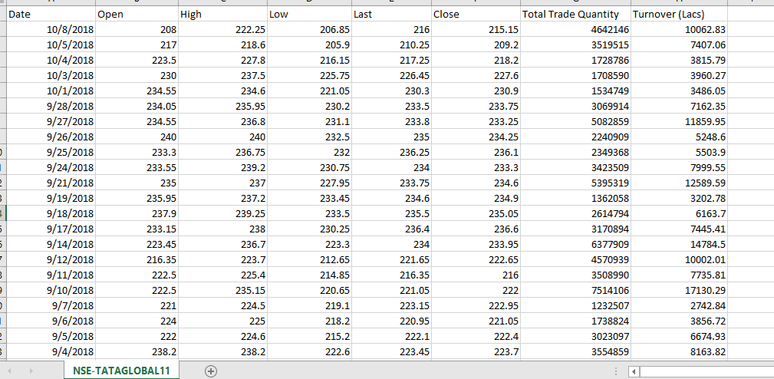

CHAPTER – 4

MODULES:

- Data Preprocessing

No data preprocessing was required for the data since it was already normalized from the site we got it (www.kaggle.com)

- Modelling of the Data

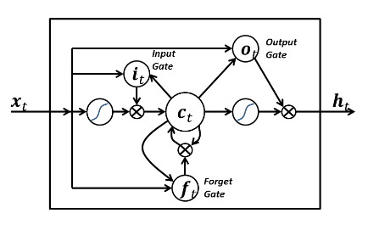
LSTM MODEL

- Algorithm

The following algorithm was applied to train the model and get the test results:

- A classification model (Figure 2) was designed based on LSTM networks so as to perform predictions of price movements for a number of stocks.
- On top of the historic price data, in order to reduce random variation and noise on the pricing series, exponential smoothing was performed through exponentially weighted moving averages (2) as indicated by [19] to cause improvements on the prediction capability.
- A binary class y is assigned to each entry of the dataset, “1” will indicate that the price will go up on the following time step, and “0” that it won't. Therefore, given that i is the current moment and j is the following, then j=i+timestep, and for this project timestep is equivalent to 15 minutes. In case the output is “1”, a “buy” operation will be triggered at i.

- Comparision

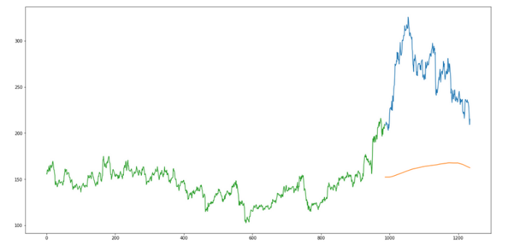
MODEL 1 – Simple

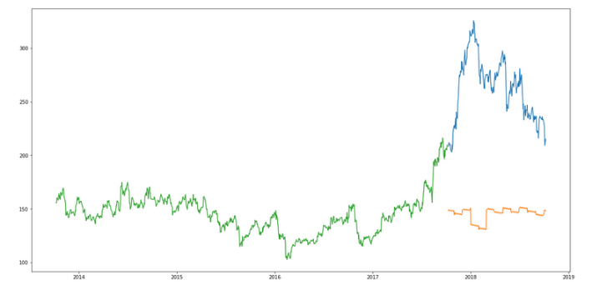
MODEL 2 – LSTM Model

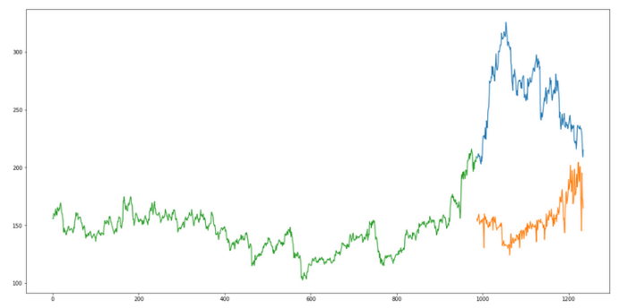
MODEL 3 – SVM Model
After comparing the above 3 models, we combine the LSTM and SVM models and got the most accurate results that were expected of it:

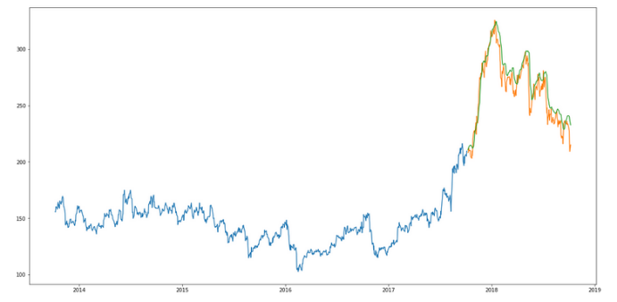

- Results and Discussions

The LSTM model can be tuned for various parameters such as changing the number of LSTM layers, adding dropout value or increasing the number of epochs. But are the predictions from LSTM enough to identify whether the stock price will increase or decrease? It's a probability.

PROTOTYPE

#using svm to predict stock
import numpy as np
import pandas as pd
from sklearn.model_selection import train_test_split
from sklearn import svm,preprocessing
from sklearn.metrics import classification_report
stock_prices = pd.read_csv(r'../input/prices.csv')
symbols = list(set(stock_prices['symbol']))
In [3]:
msft_prices = stock_prices[stock_prices['symbol']== 'MSFT']
msft_prices = msft_prices[['date','open','low','high','close','volume']]
msft_prices.to_csv('msft_prices.csv',sep='\t')
msft_dates = [pd.Timestamp(date) for date in msft_prices['date']]
In [4]:
msft_close = np.array(msft_prices['close'],dtype='float')
import matplotlib.pyplot as plt
plt.title('MSFT')
plt.scatter(msft_dates,msft_close)
plt.show()

CHAPTER – 5

PROJECT TIMELINE:

MONTH | ACTIVITIES PERFORMED/TO BE PERFORMED
January | - Online Courses regarding Machine Learning and Stock Markets  - Explored Data Sets
February | - Completed with the online courses  - Read research papers  - Started building algorithm
March | - Made the modules  - Trained the LSTM model  - Finalized the first part of the project  - Prepared Investor’s Formula/Algorithm
April | - Implemented the formula  - Completed source code  - Final Training, Testing and Validation was done.
Post April/Future Work | - Start working on sentiment analysis phase of the project  - Will work on the GUI

FUTURE WORK AND CONCLUSION:

We can observe that in general the model proposed on this article outperforms the baselines with few exceptions. The outcomes can be considered very promising as it has proven able to predict well compared to other approaches employed today in the literature.
Although the input dimension is very large, the algorithm has demonstrated acceptable capability to learn from it without the need of any dimension reduction technique like feature selection, for example.
When compared to the other machine learning models it has displayed considerable gains in terms of accuracy, but in another hand we believe that variance could be lower and that would contribute for a more reliable model.
When it comes to the financial results it's important to note that it was able to keep it positive for all stocks, even though it didn't necessarily had the best results when compared to the baselines.
Another positive aspect is that it had a high return ratio per operation, meaning that it had more success on detecting high variations which is extremely important when account transactions costs and taxes are taken into account.
Besides that, when observing the maximum losses it is possible to conclude that the LSTM based model offers less risks when compared to the other strategies.

REFERENCES

Journal / Conference Papers

[1] Ashish Pathak, Nisha P Shetty – Indian Stock Market using Machine Learning and Sentiment Analysis, Manipal Institute of Technology
[2] Tongda Zhang, Shunrong Shen, Haomiao Jiang – Stock Market Forecasting using Machine Learning Algorithms, Stanford University
[3] Rohit Choudhry, Kumkum Garg – A Hybrid Machine Learning System for Stock Market Forcasting, World Academy of Science, Engineering and Technology ,2008
[4] E. F. Fama and B. G. Malkiel, “Efficient capital markets: Areview of theory and empirical work,”The Journal of Finance,vol. 25, no. 2, pp. 383–417, 1970. [Online]. Available: http://dx.doi.org/10.1111/j.1540-6261.1970.tb00518.x
[5] B. G. Malkiel, A Random Walk Down Wall Street. Norton, New York,1973.

Web

- https://www.slideshare.net/PaaPpUU/the-study-of-stock-market - The Study of Stock Market, Shweta Acharya
- www.coursera.com

